**SALES AUTOMOBILE USING SALESFORCE CRM**

**Email:** [gsathish212003@gmail.com](mailto:gsathish212003@gmail.com)

**Name:** SATHISH KUMAR.G

**NM ID:** 7283A72FDD6DBA7A1DB4743872786DF9

**Team members:** YUVARAJ.M, PRITHIVIRAJ.S, TAMIZHENTHI.M

**ARUNAI ENGINEERING COLLEGE**

**1.Project Overview :**

This project is focused on creating a comprehensive Salesforce Automobile Information CRM, designed to address the challenges of managing and tracking automotive sales, inventory, and customer relationships in the automobile industry. The goal is to deliver a solution that leverages Salesforce CRM, cloud technologies, and automation to improve the management of customer interactions, streamline inventory tracking, and optimize sales processes. Through this project, we aim to enhance operational efficiency, customer experience, and data accuracy, while supporting the long-term goals of the automobile dealership or sales organization.

**2.OBJECTIVES:**

**Business Goals:**

- Streamline the management of customer data, vehicle inventory, and sales processes.

- Enhance customer engagement through personalized service and targeted marketing.

- Improve operational efficiency by automating routine tasks and workflows.

**\*Specific Outcomes:\***

**-** Develop an integrated system for tracking vehicle inventory, customer inquiries, sales leads, and follow-ups.

- Implement automated workflows for sales, service, and customer support processes.

- Enable detailed reporting and analytics for performance monitoring and decision-making.

- Ensure seamless integration with other systems like financial and service management tools.

**3. Salesforce Key Features and Concepts Utilized:**

This section highlights the main Salesforce functionalities applied in this CRM system:

- **\*Salesforce Sales Cloud*:** Used for managing leads, opportunities, and sales pipelines.

- **\*Salesforce Service Cloud*:** Provides customer service functionality, including case management and customer support.

- **\*Custom Objects and Fields*:** Created to track vehicle information (make, model, year, VIN, etc.) and manage inventory.

- **\*Apex Triggers and Classes*:** Used to automate processes such as updating inventory status, sending notifications, or creating follow-up tasks for sales representatives.

- **\*Reports and Dashboards*:** For real-time insights into sales performance, customer activity, and inventory levels.

- **\*Lightning Web Components (LWC)*:** Custom user interfaces for improved user experience and interaction with the CRM.

**4. Detailed Steps to Solution Design:**

- **\*Data Models:\***

- Define custom objects like *Vehicle Inventory, **Customer, and **Sales Opportunity* to store all relevant data.

- Establish relationships between objects such as *Customer to Sales Opportunity* and *Vehicle Inventory to Sales Opportunity*.

- Design custom fields in each object (e.g., *Vehicle Color, **Model Year, **Price, **Customer Preferences*).

- **\*User Interface Design:\***

- Create custom Lightning pages for sales reps, service agents, and management to easily access and update information.

- Utilize *Lightning App Builder* to create a user-friendly dashboard that displays key metrics such as active sales leads, available inventory, and customer interactions.

- **\*Business Logic:\***

- Define automation rules for sales and service processes (e.g., automating lead assignment, setting up reminders for follow-up, and creating tasks based on specific triggers).

- Use *Flow* and *Process Builder* to streamline sales workflows, such as sending automated emails to customers after a purchase or sending alerts when inventory is running low.

- **\*Relevant Screenshots:\***

- Include wireframes and Salesforce page designs to illustrate the user interface and workflow steps.

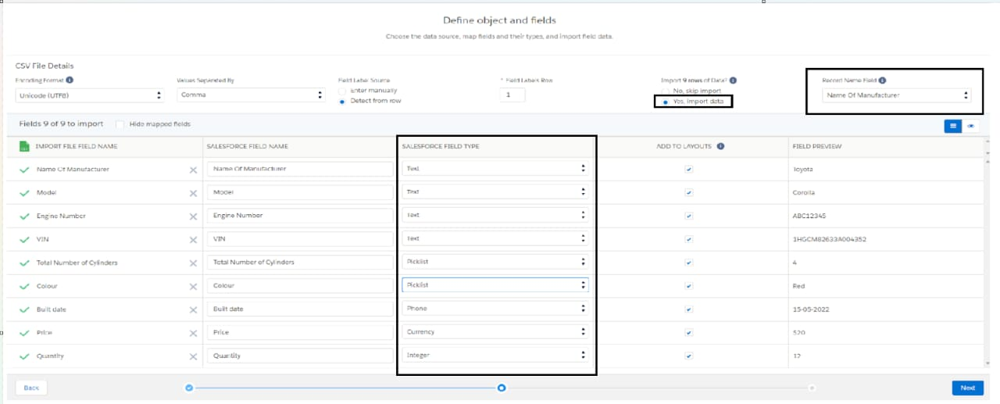

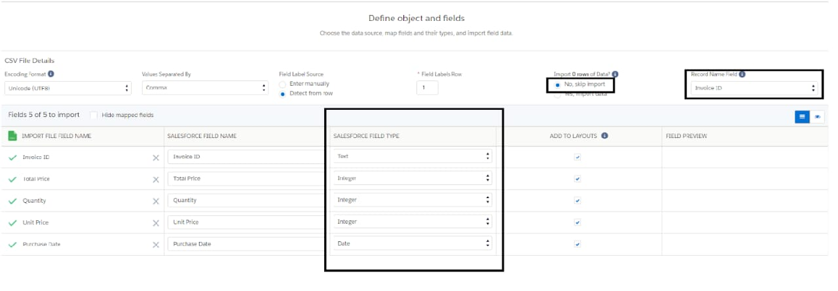

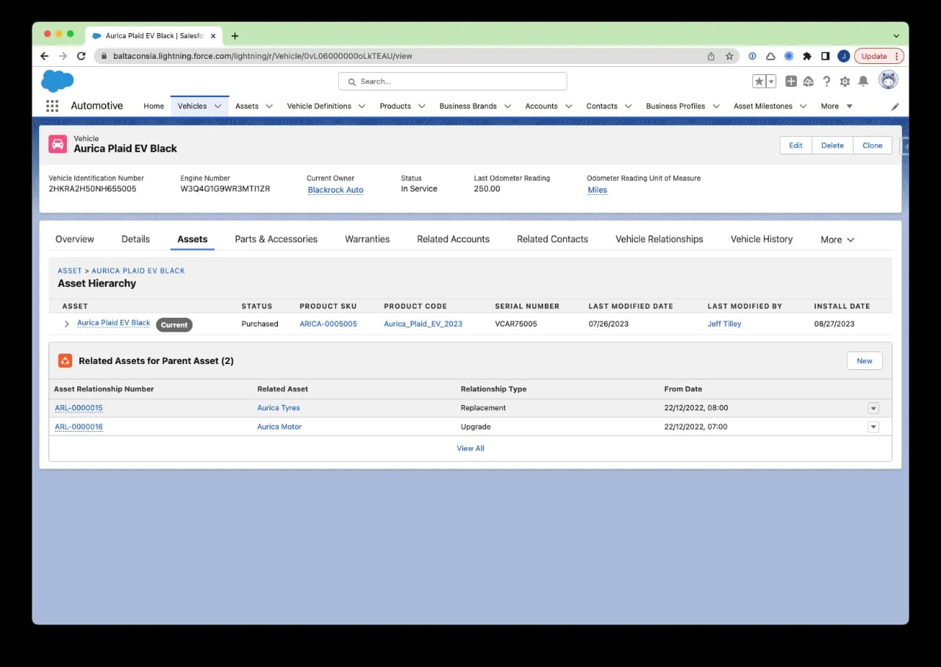

**6. Key Scenarios Addressed by Salesforce in the Implementation Project**

- **\*Lead Management*:** Automating the process of capturing, tracking, and converting leads into sales opportunities.

- **\*Inventory Management*:** Using Salesforce to track and update the status of vehicle inventory in real-time.

- **\*Customer Communication*:** Automating follow-ups, sending personalized messages, and tracking customer preferences for improved service.

- **\*Sales Analytics*:** Using Salesforce’s built-in reporting tools to monitor sales performance, customer interactions, and inventory turnover.

- **\*Customer Service*:** Providing post-sale support, tracking service requests, and handling customer inquiries via Service Cloud features.

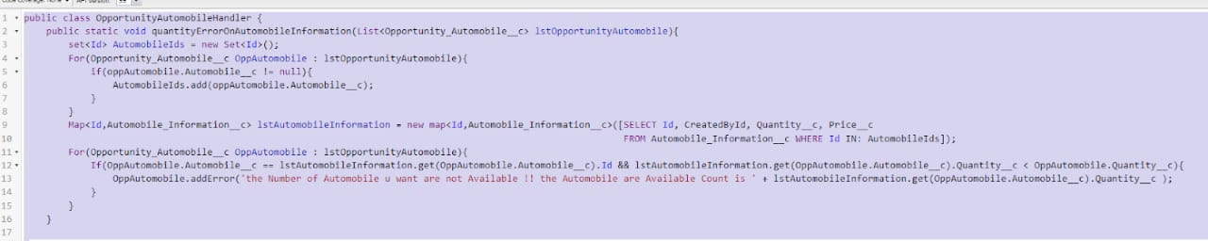

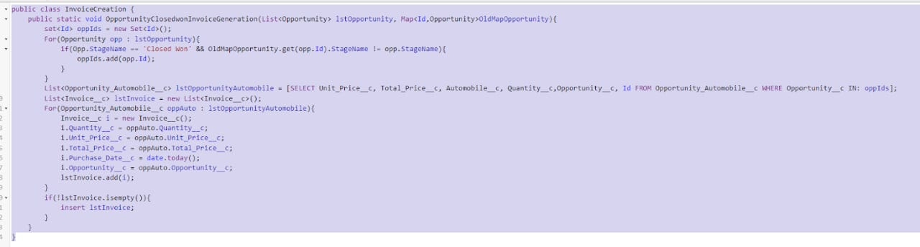

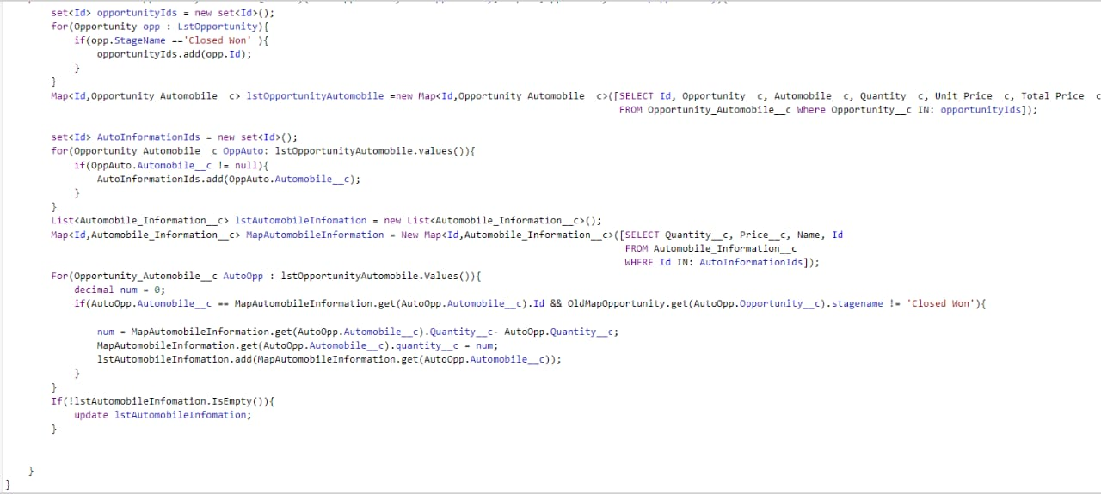

**7. Conclusion**

**\*Summary of Achievements:\***

The Salesforce Automobile Information CRM project has successfully integrated sales and service functionalities into a single platform, improving both internal operations and customer satisfaction. The CRM system now allows seamless tracking of inventory, sales opportunities, and customer interactions while automating key processes to boost efficiency. With enhanced reporting and analytics, the organization can make data-driven decisions to grow their business and improve the customer experience. The solution is scalable, customizable, and alignswith the long-term goals of the automobile dealership, setting a foundation for future growth and digital transformation.